**Getting Started**

**Request a Professor Account**

At the bottom of the page you will see “Request Professor Account”. Click it…



Provide your full name and your UWEC email to the form and submit.

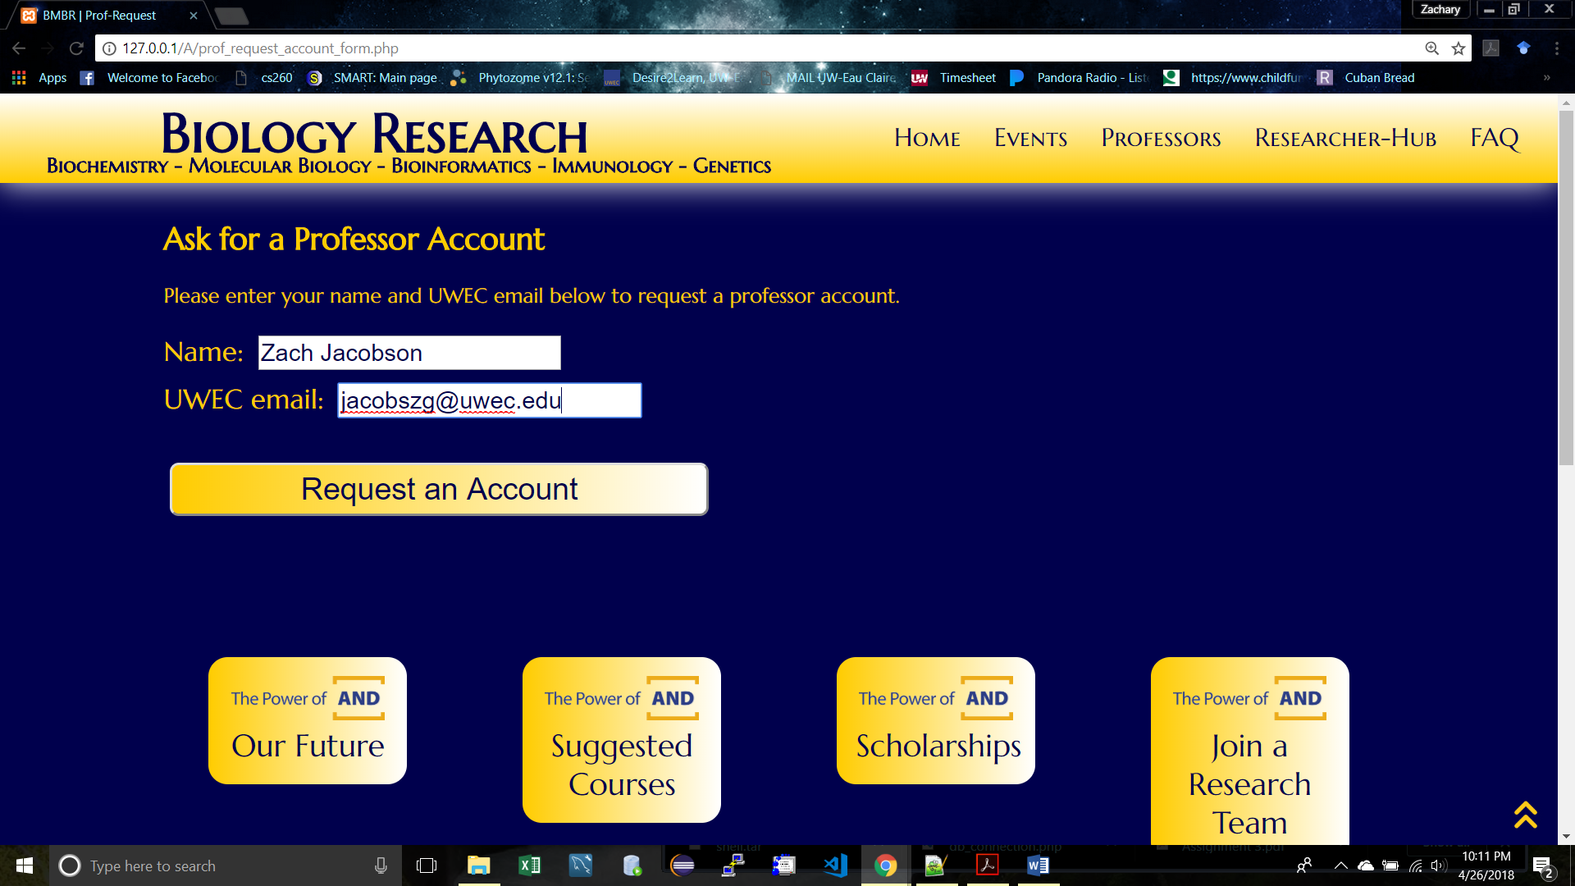

Now you will need to wait for a temporary account to be approved by a current professor. Once you are approved you will see a weird email that looks like the one below. You can now login using the TempUser account provided in the email.

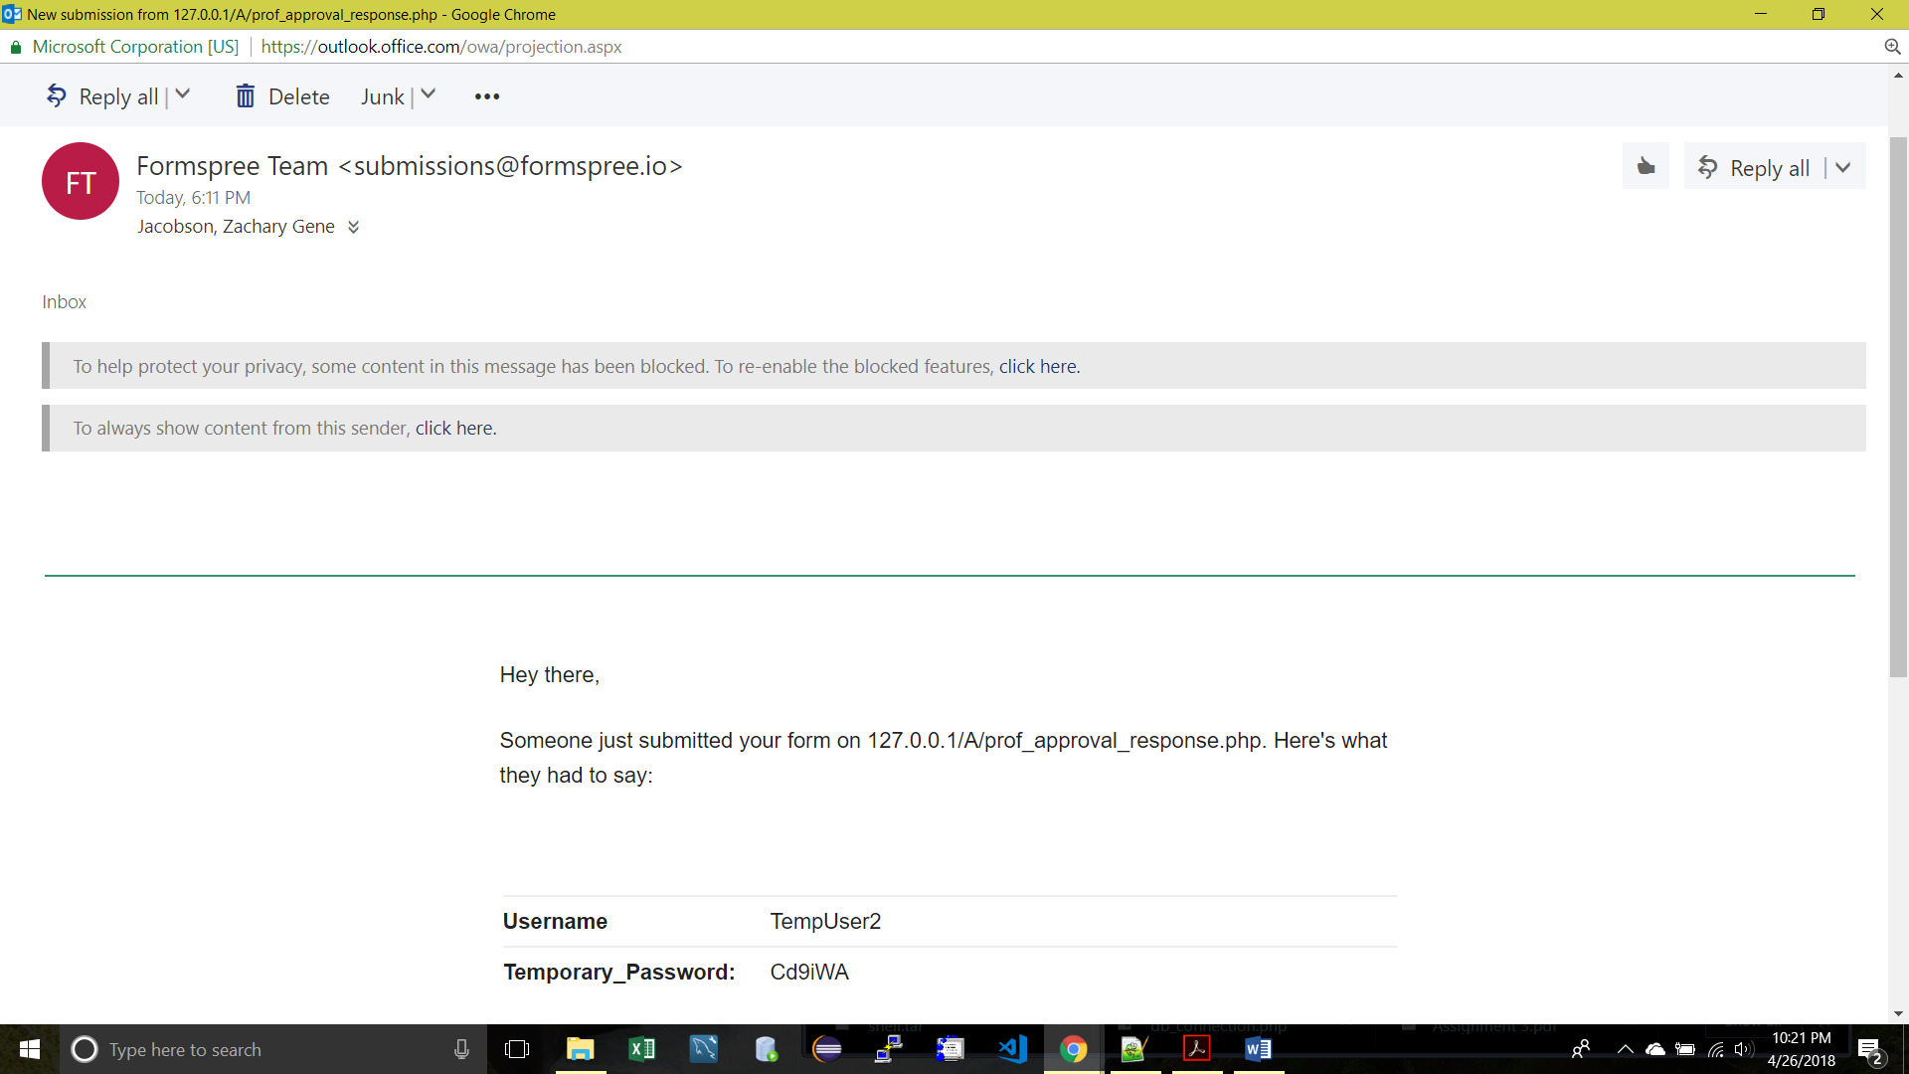

**First Login**

You can use that TempUser information to login for the first time. Click “Professor Login” at the bottom of the BMBR page.

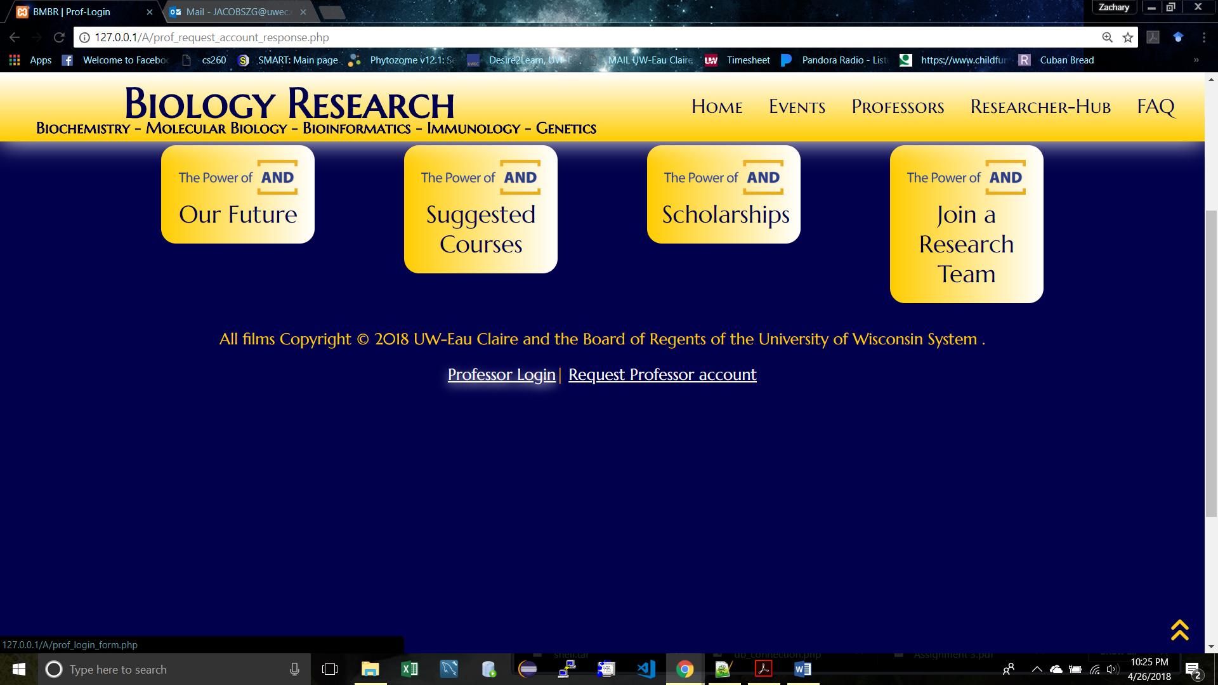

You will now need to fill out the form completely and accurately

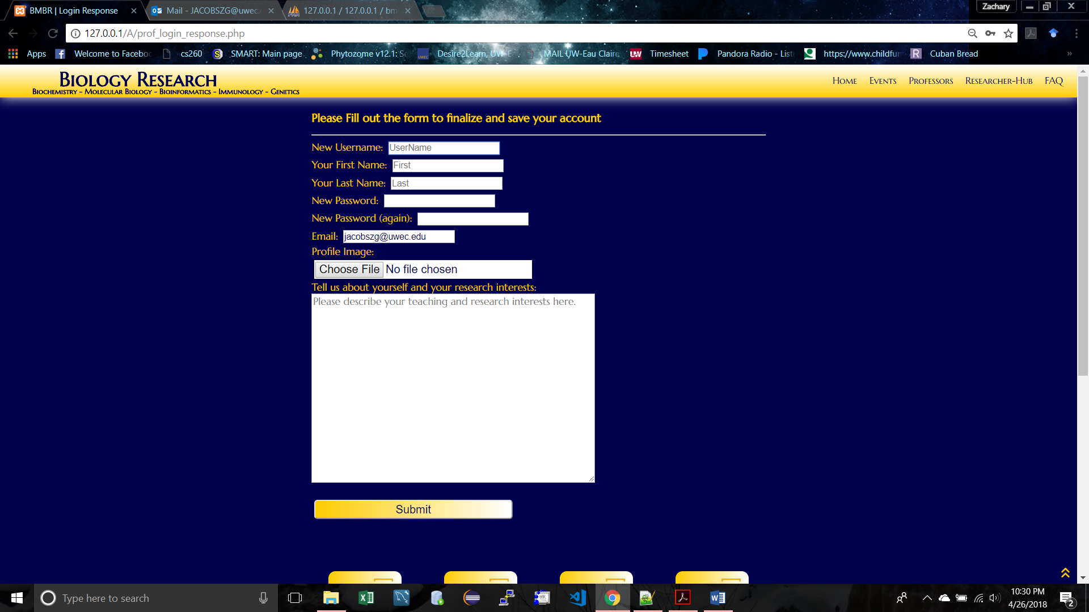

If you make an error and submit, or the submission does not work correctly you can always delete your account and request a new one (not great, but workable).

There are some safeties in place for you the user (like you will not be able to submit unless you have the whole form filled out in some manner), but typos and bad photos (either in the technical or aesthetic sense) cannot be changed; only deleted by deleting the entire account.

**SILENT FAIL** if you try and load a very large image as your profile image it will not be uploaded, but your account will continue to be created. You will want to delete the failed account and try again.

**Posting Messages**

**Be sure to not try and load anything too big (this limit is set on the server side)**

This is what a good post looks like after you ‘Upload New [something]… 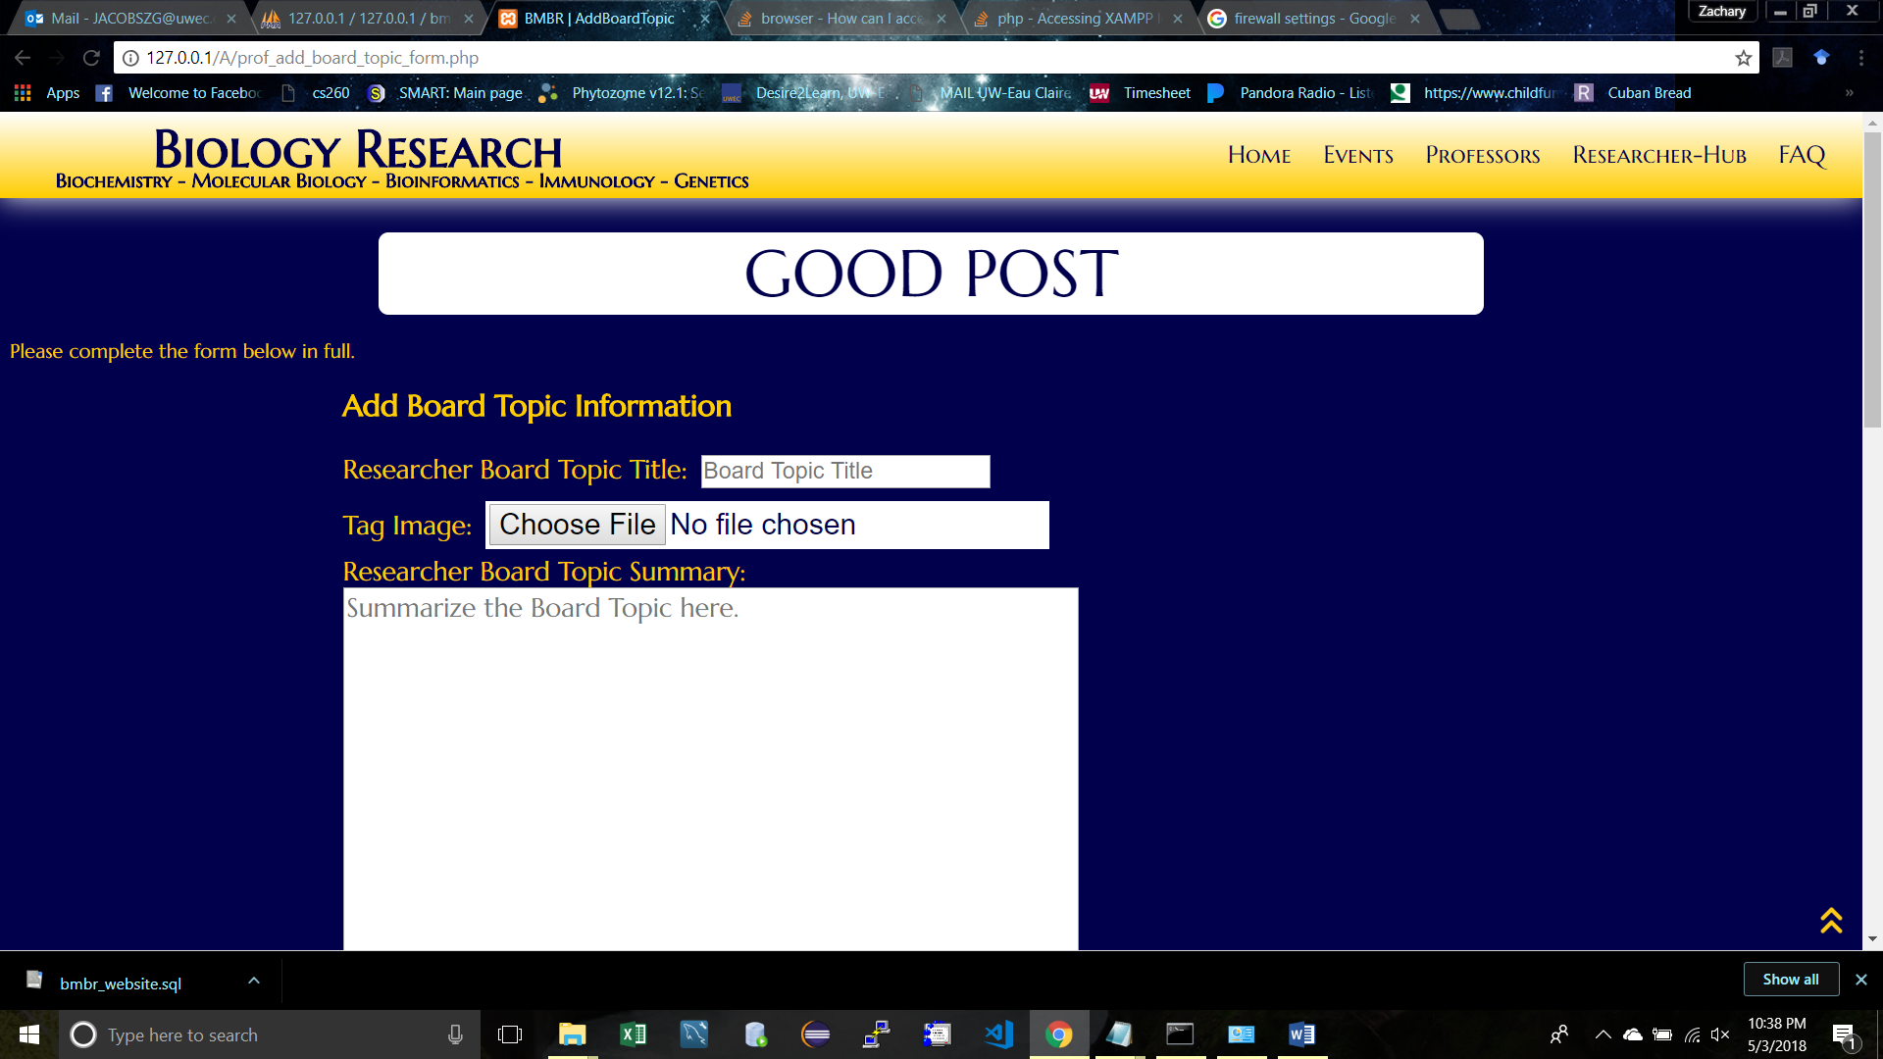

This is what happens when a file is too big (notice no ‘GOOD POST’ message and a gap appears).

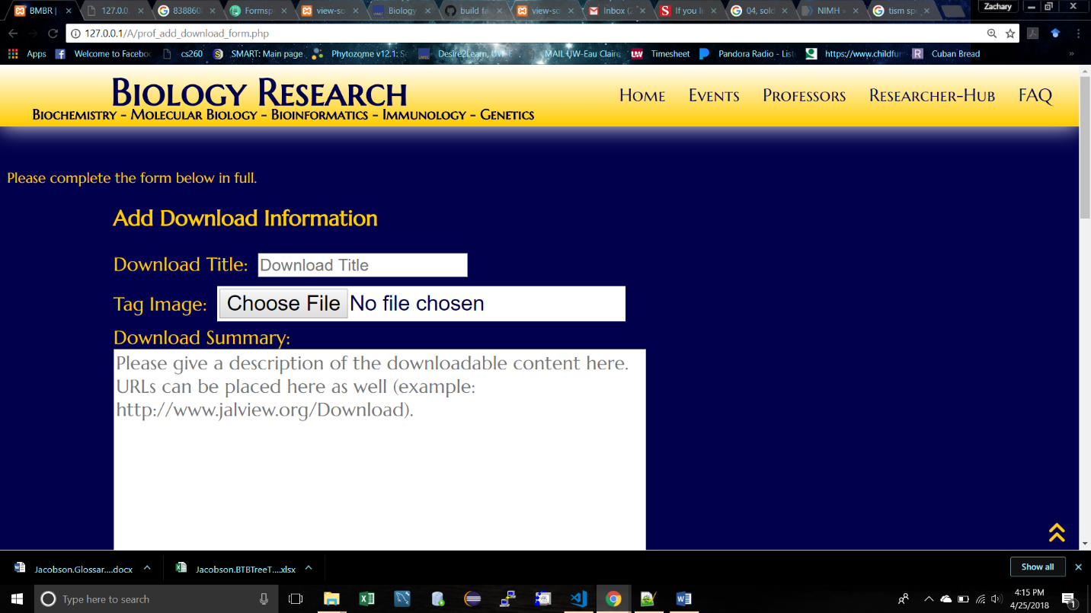

This is not quite a silent fail, as the computer is still trying to tell you it did something (in a whispering sort of way). Since it was not uploading your file, who knows what that things may be… I believe it wrote what it could into the database and respective directories, where those written additions may or may not be reflected on the actual website… it really depends on which piece of the form the user confused the poor computer on.

There are other error messages that can occur if you try hard enough (please don’t). You should be able to return to the form hitting the white “Return” or move to a different page without breaking any part of the website or database.

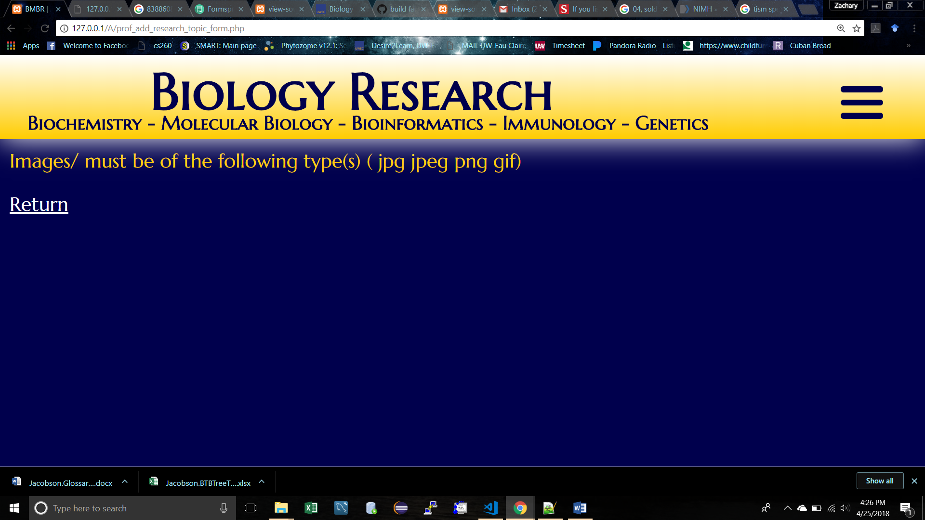

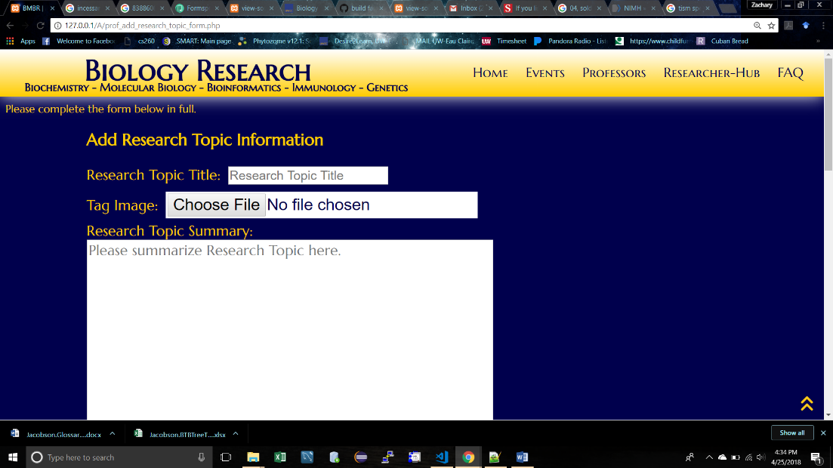**No Message?** If you try and add [something] and no messages appear and there is no shift on the top, then you have found a silent ‘FAIL TO POST’ and you will have to redo the post. This usually only happens when one of the fields have not been completed (hence the incessant “Please complete the form in full” message at the top). Sometimes the files take a second to actually “set” into the form and submitting the “Add New [something]” before they are ready will cause this. I would prefer a silent fail over a whispering fail any day…

**Approve/Deny a Professor Account Request**

When you login you may notice a name and email (or a list of names and emails… but hopefully just a single name and email for reasons explained later).

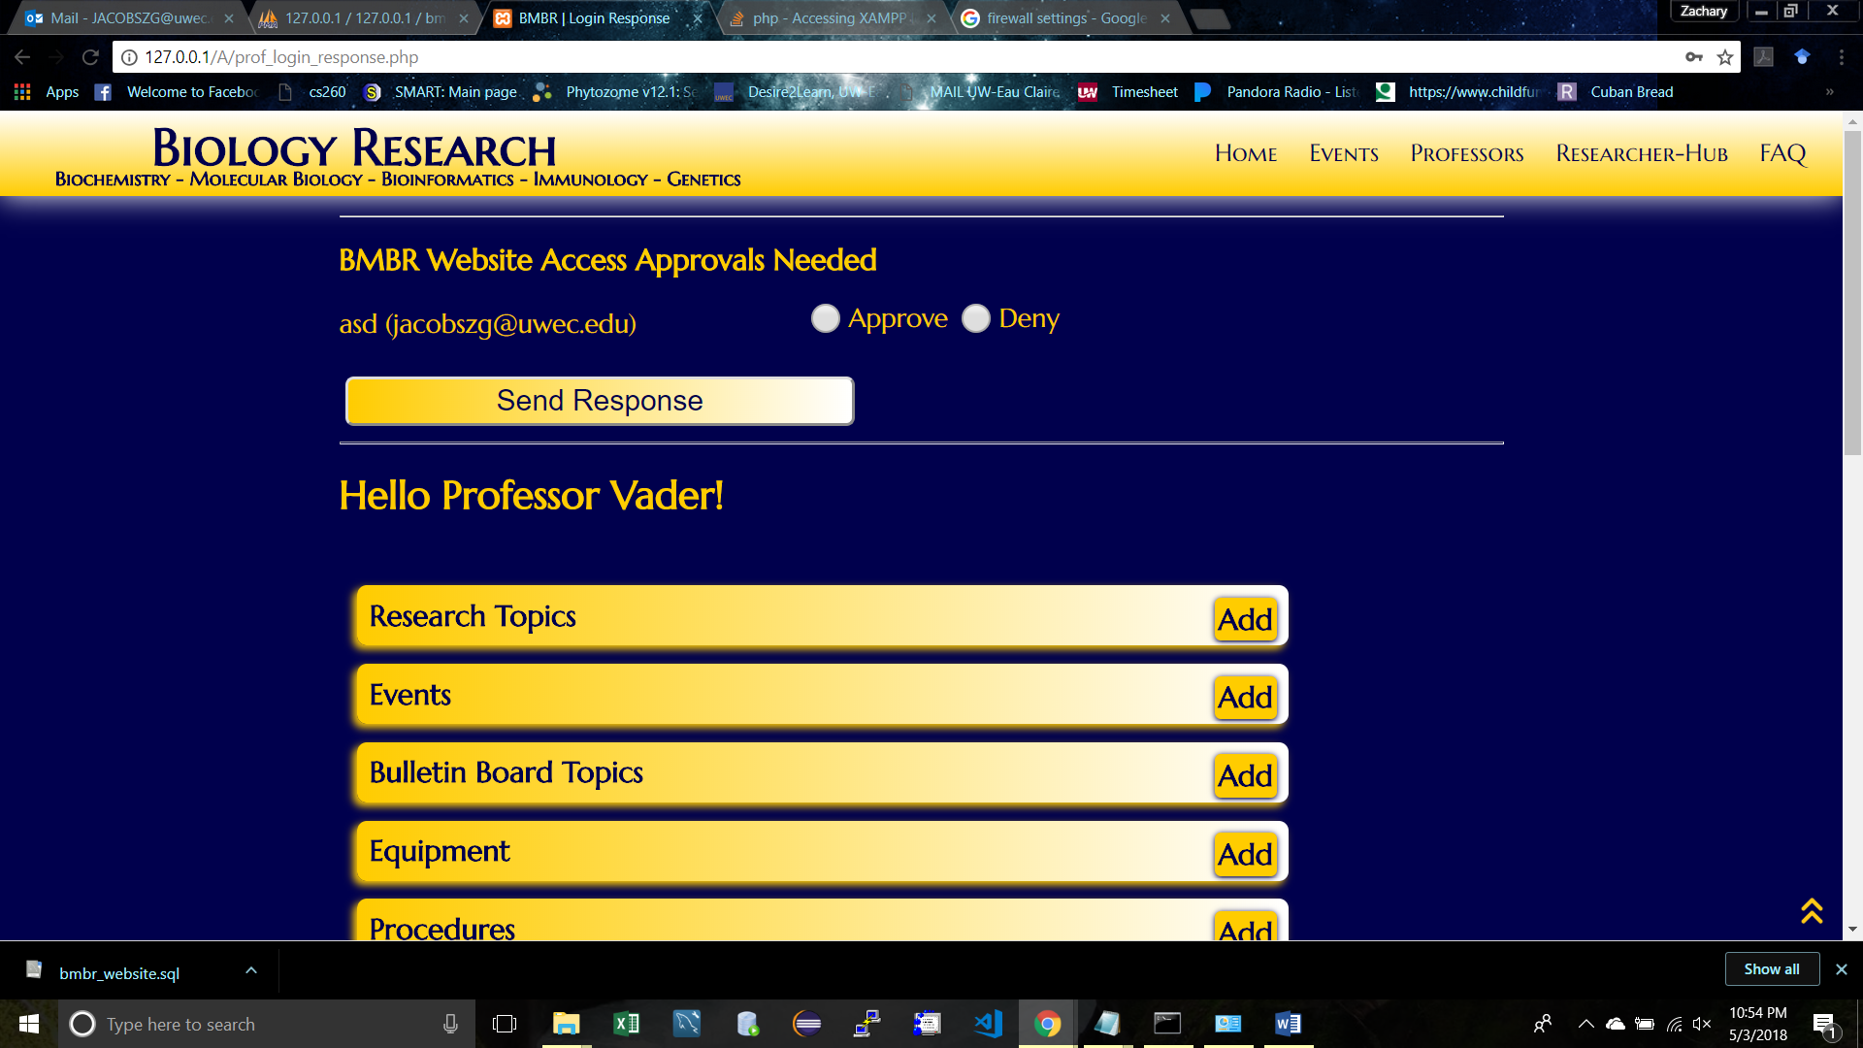

If you recognize that email associated with that name then select the approve (otherwise deny the request) and “Send Response”.

If Denied you should see…

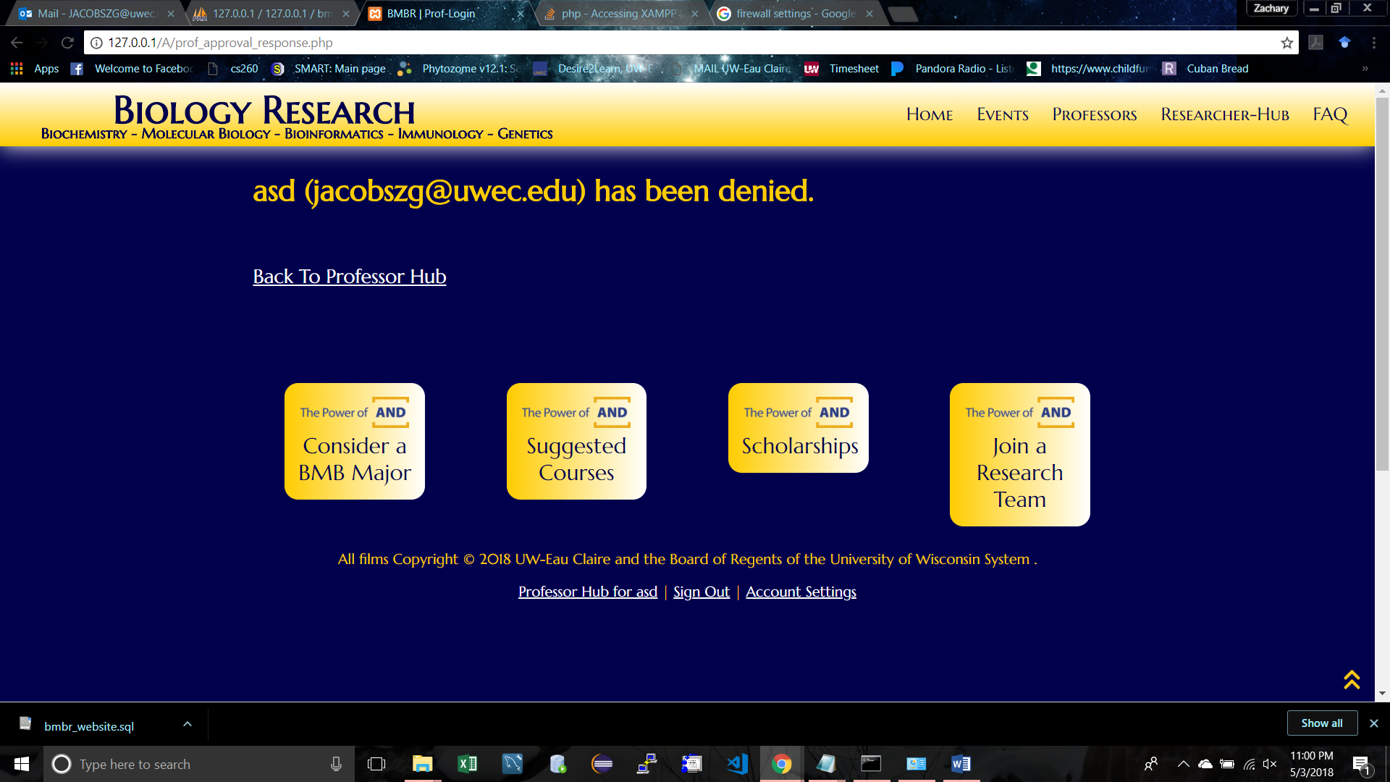

If Approved then you should see…

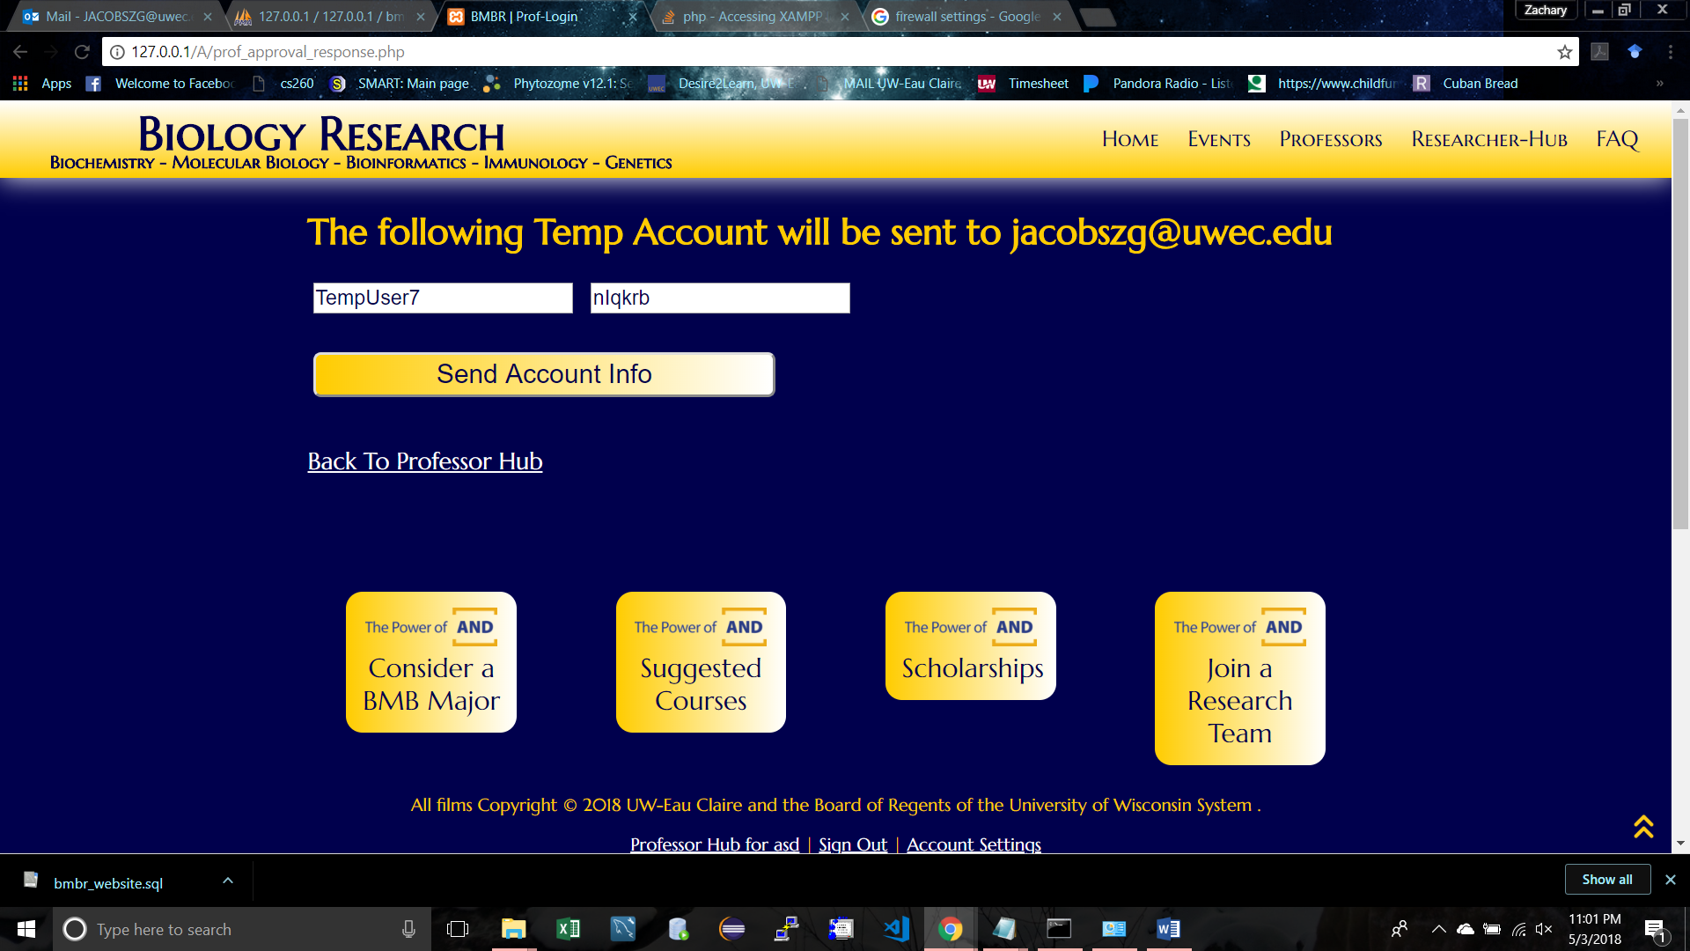

At this point of the approval process you have created this TempUser account in the database, but you still need to push that TempUser account information to the person who requested it. To email them this information just hit “Send Account Information”. You will be brought to a new tab that will ask you questions. Just agree to these questions. They will look like this…

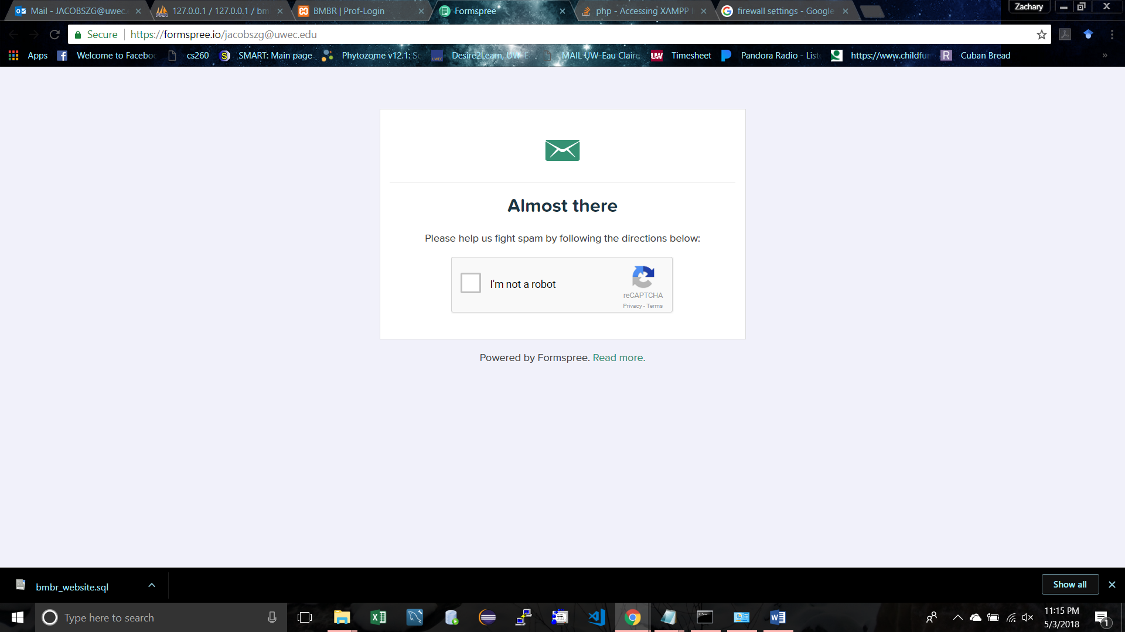

Once you complete the questioning you will notice the BMBR website still up in the tab you just left. Go back…

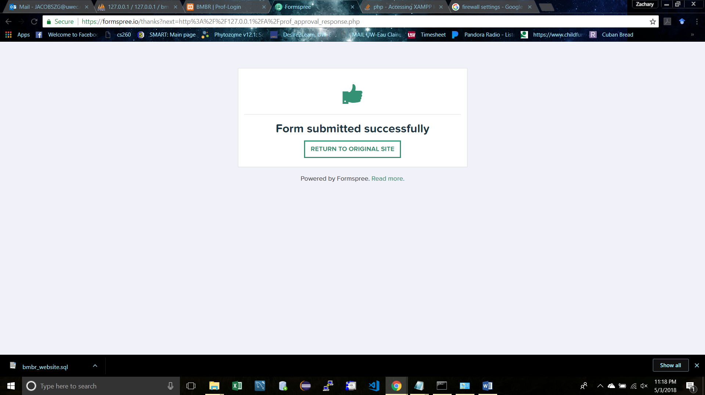

Once back you will notice that absolutely nothing has changed. Which is terrible because you are finished with this task and no longer need to “Send Account Information” (unless you want to spam that professors inbox with “Formspree” mail).

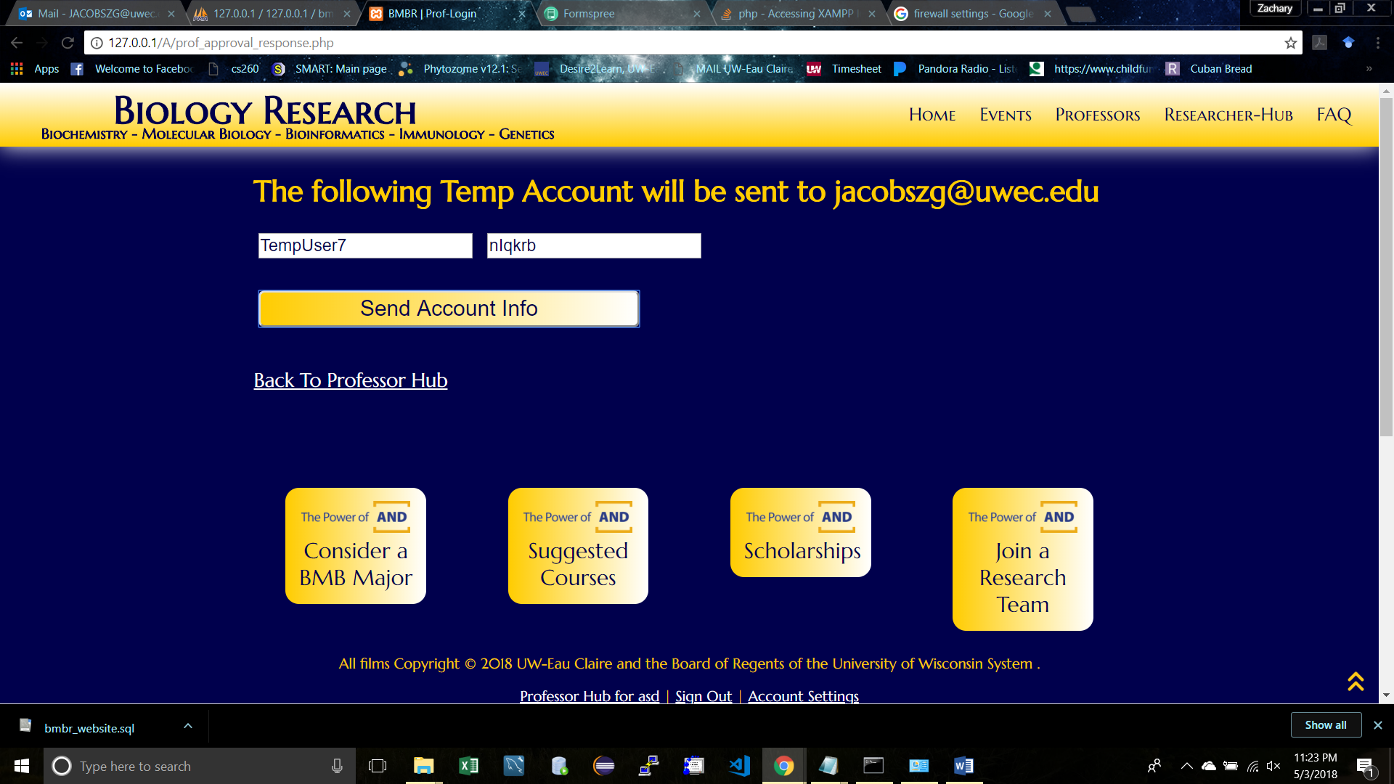

**Fringe Cases and Unlikely Scenarios**

Note, if you navigate away from this page before pressing “Send Response Info” at least once then you will have not sent the account information to the professor who requested it, but the temp account will still be stored on the database forever (or until someone makes a timeout delete function to delete all TempUsers after a certain point of creation, or someone just physically deletes it from the server). Which brings up an issue… If there is a TempUser account sitting in there with the other professors, then the next time someone actually creates an account, that TempUser account will propagate itself into the Professors page as a blank yellow rectangle… Since no one was emailed that TempUser account information that blank yellow rectangle will just sit there until the Temp account is deleted from the database.

This can also happen if anyone approves more than one person at a time. The first time some one logs into a temp user account and finalizes it to their own account, then the other temp user accounts will again be propagated into the Professor page. The only difference is that those Temp User Accounts will eventually be converted into actual professor accounts, making those blank yellow rectangles become filled with “Professor such’n such”.

Long story short hit the “Send Account Info” button so the requesting professor can make an actual account (or at least write down temp user account information so you can access it from the website later for deletion).

**The Fix (that has yet to be done)**

You can solve most of this by disabling the Submit buttons (or at least prompting the professor to not click it again, and not let them leave the page until they send the email… You will have no control over if they actually finish the Formspree side though… which leaves us back to square one if they fail at that…